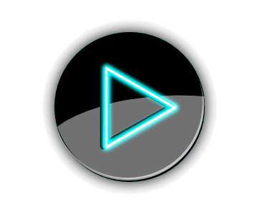

Raspberry Pi Music Player

BY:Abdulaziz AlTamimi
Abdulaziz Mutahar
Kamyab Karimi

Abstract
The equipment that you’re going to need for this Raspberry Pi music player is listed below. I have also made a mention of a few devices you can use to get better audio from the Pi.
Required
Raspberry Pi
8 GB SD Card or Micro SD Card if you’re using a Raspberry Pi 2 or B+
Ethernet Cord or Wi-Fi dongle
31/1/16 | Version 1 | The plan
1/2/16 | Version 2 | First draft
2/2/16 | Version 3
4/2/16 | Final version

Table of Contents
TITLE P1
Abstract P2
Music Player P3
Introduction P4
Steps P5
Reference P6

Music Player Pi
If you’re looking use services such as Spotify, YouTube, Google Music, Sound Cloud and much more then you will need to set them up in here. The setup for each of the services are pretty straight forward and are often explained if any extra information is required. More services may be added in the future.
That’s basically all the information you should need for setting up the music player correctly.

Instruction
We will get speakers to connect them with the raspberry pi and connect it with the device to make the sound loud and clear. We also we need 8 GB SD Card or Micro SD Card if you’re using a Raspberry Pi 2 or B+ Ethernet Cord or Wi-Fi dongle so we can make it work perfectly.

Step By Step
1. First we need to download the Pi Music Box zip from their website here.
2. You are also going to need a formatting tool. To get one simply visit the SD Association’s website and download SD Formatter 4.0 for either Windows or Mac.
3. Follow the instructions and install the formatting tool.
4. Now insert the SD card into the computer or laptop’s SD card reader and check the drive letter allocated to it, e.g. G:/
In the SD Formatter tool, select the drive letter for your SD card (eg. G:/) and then press format

GUS. "An Amazing DIY Raspberry Pi Music Player - Pi My Life Up." Pi My Life Up. 2016. Web. 08 Feb. 2016. <http://pimylifeup.com/raspberry-pi-music-player.

