Raspberry Pi

  - Computer Graphics
  - Astronaut Reaction Time Game

By Jocelyn Kahendaguza and Sakiko Ominato

Abstract

In this document you will install a game called Astronaut Reaction Time Game to Raspberry Pi. Just follow the instruction and you will have the game! We did this project in the Computer Graphics class in pairs. Enjoy exploring the technology.

Content List
- Project description
What is Raspberry Pi ?
Which program do you install in this project?
What will you learn?
- What you need
- Start your Raspberry Pi
- Install guide
- Bibliography

Project Description

What is Raspberry Pi?
A credit-card sized computer that plugs into a computer monitor or TV, and uses a standard keyboard and mouse. It is a capable little device that enables people of all ages to explore computing, and to learn how to program in languages like Scratch and Python.
(Resource URL: https://www.raspberrypi.org/help/what-is-a-raspberry-pi/)

Which program do you install in this project?
You install a game called Astronaut Reaction Time Game. You can find this project by accessing Raspberry Pi webpage-> Education on the upper bar-> resources-> Astronaut Reaction Time Game (URL: https://www.raspberrypi.org/learning/astronaut-reaction-times/). In this game you will create a game using Scratch.

What will you learn?
By creating a Scratch reaction game you will learn:
- Why astronauts need to have super-sharp reactions in space, and the average distance travelled by the ISS.
- How to import images into Scratch and use them as backgrounds and sprites.
- How to store data like time and distance in variables.
- Use multiplying operators to calculate distance travelled by the ISS
(Resource URL: https://www.raspberrypi.org/learning/astronaut-reaction-times/)

What You Need
- Raspberry Pi
- SD card
- Keyboard and mouse
- power supply
- Display and connectivity cables (HDMI)

Start Your Raspberry Pi
- Plug your HDMI to your Raspberry Pi
- First put in an SD card, plug in a power cord, keyboard and mouse
- Press '+input' button on your computer
- Follow the steps 'how to make a game'
- Try it out
- When fit to your expectations, save the game
(URL: https://www.raspberrypi.org/help/quick-start-guide/)

Install Guide

Set The Stage With A Space Theme
- If you are using a Raspberry Pi you can open Scratch by clicking on Menu and Programming, followed by Scratch.
- Create a new file by selecting File and New.
- Delete the Scratch Cat sprite by right-clicking on it and selecting Delete from the menu that is displayed.
- For this project, you need a space-themed background and an Astronaut sprite. To add a background in Scratch, click on stage in the sprites palette and then click on Backgrounds next to the scripts tab.
- Next, add a new sprite by clicking on the import a new sprite icon on the sprites palette (which looks like the image below), selecting Astronaut-Tim from the choices and clicking OK.
- Save your Scratch project work by clicking on File and Save As. Name your program Astronaut Reaction Game and save it in your home directory or some place that you can find it later.

Create Variables To Store Data
- To create a variable, click on Variables in the blocks palette and then click Make a Variable. The New Variable window opens and asks you to type a name for your variable.
- Name the first variable time and ensure that for all sprites is checked before clicking OK. A variable holds a value that can be changed. The time variable you have created is an example of a value that can be changed and used inside different scripts. You will use it to store the reaction times of players.
- You’ll see some orange blocks are added to your Variable area called time, and a small counter box will appear on the stage.

Begin The Reaction Game Script
- Click on your Sprite to select it in the sprites palette.
- Select the When green flag is clicked control block from the blocks palette and place it onto the scripts area.
- Then click on Looks and connect the say for 2 secs block to the first control block on the scripts area. Amend the text to say Hello! British ESA Astronaut Tim Peake here. Are you ready?.
- Search US Keyboard on Google, go to images. Find where to press to insert ! mark. You need this step because you have a different type of key board.
- Add a wait 1 secs block underneath.
- Connect another say block and change the text to Hit Space!.
- Click on Sensing and connect the reset timer block. This will set the timer to 0 so that you will get an accurate measurement of how long it takes for someone to hit the space bar.
- Use the control block wait until and place a key space pressed? sensing block inside the white space of the wait until block. This will pause the program until the player presses the space bar.
- Then connect another say block. Once the space bar has been pressed, you want to display the reaction to the player. To do this, you need to place an operators block called join hello world inside the white space in the say block. Replace the word world with the word seconds.
- You will then need to replace the word Hello with another join hello world operators block, replacing the Hello text with Your reaction time was and the world text with the timer sensing block.
- Finally, select the set time to block from the variables section and add it to your script. Place the timer sensing block inside where it reads 0.
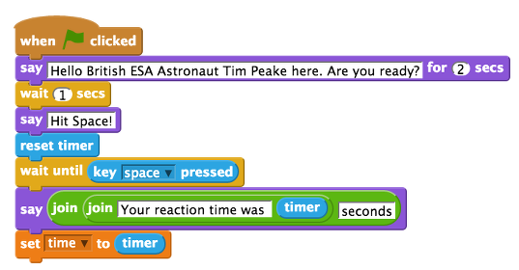
- Save your game and test it works by clicking on the green flag. When Tim says "Hit Space!", press the space bar. Your time should be displayed like this:
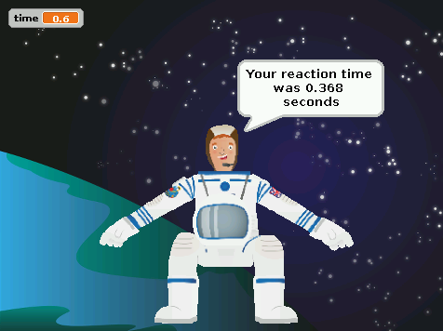

Comparing Player’s Reaction Time To The ISS Orbit
If you are happy with your reaction game and have tested that it works, then you can move onto adding to the script to compare the player's reaction time to how fast the ISS is travelling, to calculate how far it would travel in that time.
- First you will need to make a new variable called distance in the same way you did earlier.
- Attach a set distance to variable block to your script. Place an operators multiply block 0*0 inside where it reads 0. To calculate the distance travelled by the ISS you need to take the player's reaction time, which is stored in the time variable, and multiply it by 7. This is because on average the ISS travels 7 kilometres per second!
- Add the time variable block into the right hand side of the multiplying operator and type 7 in the other side, so that the whole block reads set distance to time * 7.
- Next, add a wait 4 seconds control block.
- Then add a say block. As in the previous step, place a join hello world block inside. Replace World with kilometres. Insert another join Hello World block to replace Hello. Replace the Hello text in this new Join block with the text In that time the ISS travels around. Then replace World with a round operator block and fill the white space with the distance variable block like this:
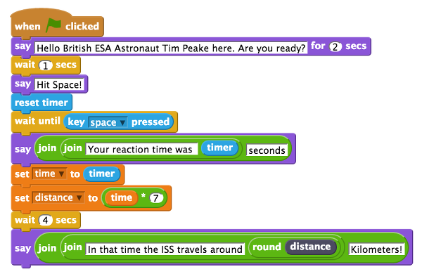
- Save your game and test that it works by clicking on the green flag.
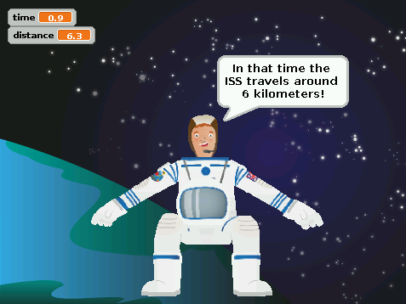

https://www.raspberrypi.org/learning/astronaut-reaction-times/worksheet/

Bibliography

Websites
https://www.raspberrypi.org/help/what-is-a-raspberry-pi/
https://www.raspberrypi.org/learning/astronaut-reaction-times/
https://www.raspberrypi.org/help/quick-start-guide/
https://www.raspberrypi.org/learning/astronaut-reaction-times/worksheet/
http://www2.le.ac.uk/departments/law/current/writing-guide-and-document-template
http://blogs.cdl.ch/cg2015/

